Description:

A German beverage company named CodeX is aiming to make its mark in the Indian market. A few months ago, they launched their energy drink in 10 cities in India.

Their Marketing team is responsible for increasing brand awareness, market share, and product development. They also conducted a survey in those 10 cities and received results from **10k** respondents to understand the Indian market.

Business task :

Convert the obtained survey results to meaningful insights that the team can use to drive actions.

Demographic Insights :

* Males prefers energy drink more compared to females and non-binary, the preference by male is almost 50% more than females.

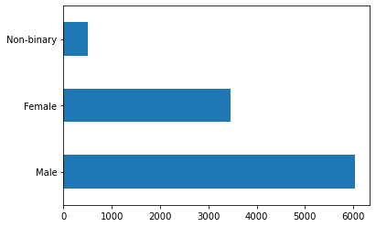

* Under the male category the age group of 19-30 prefer energy drink the most.

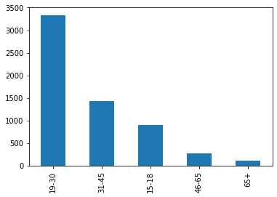

* The age group between 19-30 prefer the energy drink the most at a number of 5520 preferences, followed by the age group of 31-45 at a number of 2376 preferences.

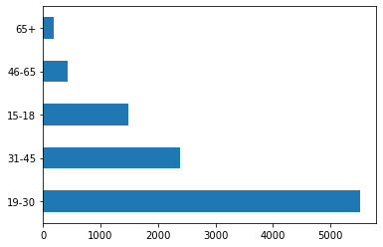

* Online advertisement reaches the most youth aged 15-30 years, the next highest reach is through TV Commercials.

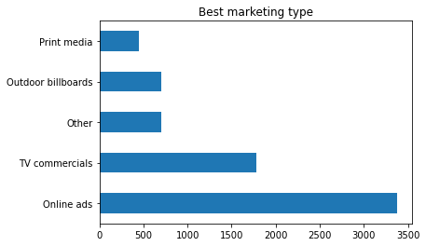

Consumer preferences :

* Some of the preferred ingredients of energy drinks among respondents are Guarana, caffeine, vitamins, and sugar, among these four ingredients the most preferred ingredients are caffeine followed by vitamins, and least preferred is Guarana.

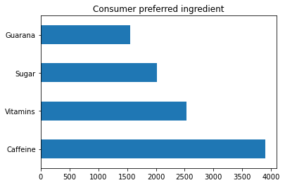

* The packing preferences of the respondents are “compact and portable cans”, ”Innovative bottle design”, “Eco-friendly design”, and “collectible packaging” and the most preferred of these is “compact and portable cans”.

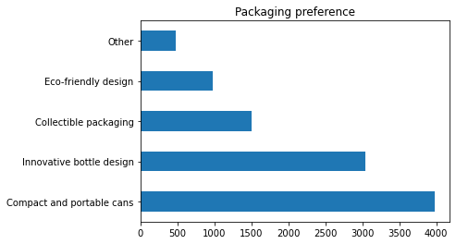

Competition analysis :

* The current market leaders are “Blue Bull”, “bepsi”, “sky9”, “cola-coka”, and “gangster”, these are the leaders that “codex” need to compete with, and among these leaders “cola-coka”, and “bepsi” lead the market in energy drink.

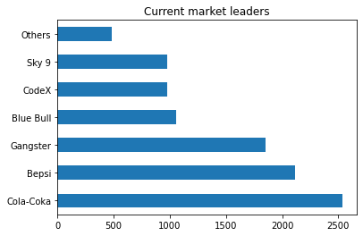

* The primary reason consumers prefer top brands like “cola-coka” and “bepsi” is because of brand reputation and taste/flavor.

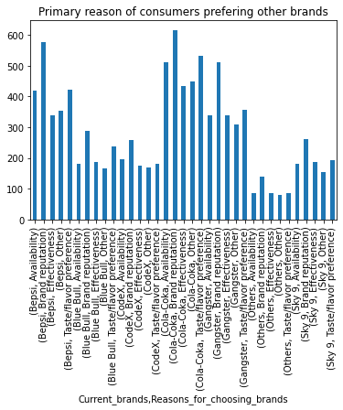

Marketing channels and brand awareness:

* Online ads is the best way to reach more customers, its almost 50% more effective than TV commercials.

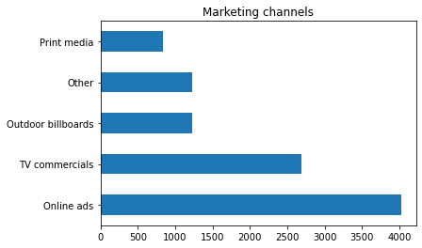

Brand penetration :

* As per brand perception majority of people are not impressed by the brand name and logo, they think that our brand name and logo is not flashy enough to attract customers. 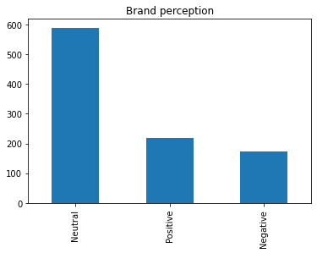
* When it comes to general perception its 50-50, half of the respondents think the product is good and effective while other half think it's in-effective and dangerous.
* Coming to the taste of the product, It has attracted a lot of respondents as lot of respondents have affirmed that the taste of the product is really good.
* The overall Rating of our product is 2.5/5
* The cities which we need to focus more on is “Ahmedabad”, “Delhi”, “Jaipur” and “Lucknow”, actually “Lucknow” is the city which we need to focus the most since it has the least response, The highest response being “Bangalore” and “Hyderabad”. 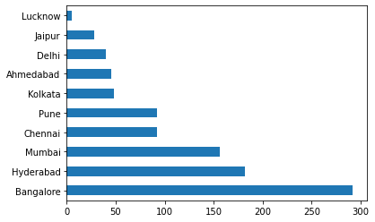

Purchase behaviour :

* Respondents prefer to purchase energy drinks at “Supermarkets”,” online retailers”, ”Gyms and fitness centers”, and “Local stores”, most of the purchase comes from “Supermarkets”

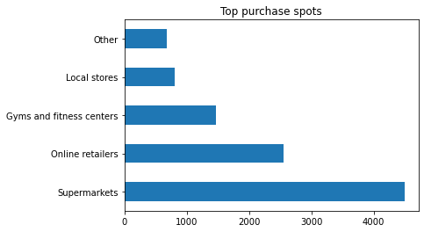

* Typical consumption situations are “studying/working late”, “sports/exercise”,” driving/commuting”, “social outing/parties”
* Consumption type of each age group, marks the highest for age group 19-30 at a consumption pace of 2-3 times a week

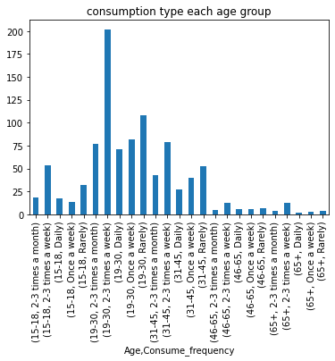

Product development :

* For product development we must focus the most in the area of Branding and availability.

Recommendations and summary:

* Since majority of respondents look for brand in the first place, hence we must focus on popularizing our brand have a flashy brand logo.
* A majority of people of concerned with health hence we should make our energy drinks healthy and Consumers should be made aware of the betterment of the product.
* Since we are making a move in a new country our prime aim will to attract more customers hence the ideal price to start with for our product will be 50-99.
* Supermarkets hold the highest number of energy drinks sold, hence we can sell most of our products through supermarkets
* Hire celebrities like a cricket star or a movie star for better branding growth and reach.